|  |  |
| --- | --- |
| **Topic** | Hazelcast |
| **Document Name** | HAZELCAST-EX-02 |
|  |  |

|  |  |  |  |
| --- | --- | --- | --- |
| **Document Difficulty Level** | | | |
| **Beginner** | **Junior** | **Senior** | **Expert** |
| □ | ■ | □ | □ |

# Document History

|  |  |  |  |
| --- | --- | --- | --- |
| Date | Author | Ver | Comments |
| **05.03.2025** | Mennan Tekbir | 1.0 | Initial Draft |
| **05.03.2025** | Mehmet Erdem Önal | 1.1 | Revisions |

# Hazelcast

## Exercise HAZELCAST-EX-02:

**Definiton:** Please pull & run hazelcast and man-center conatiners in your local machine. You may use the following Docker commands:

docker pull hazelcast/hazelcast:latest

docker run hazelcast/hazelcast:latest

docker pull hazelcast/management-center:latest

docker run --rm -p 8080:8080 hazelcast/management-center:latest

**Docker Hub Repo for Hazelcast:** <https://hub.docker.com/r/hazelcast/hazelcast>

**Docker Hub Repo for Hazelcast Management Center:** <https://hub.docker.com/r/hazelcast/management-center>

Please provide screenshots to show your work once the installation is complete.

## HAZELCAST -EX-02 Solution:

**Your Answer:**

You may provide **Hazelcast Installation and Running Steps:**

1)I pulled the Hazelcast image from Docker Hub.

2)I ran the Hazelcast container and exposed the default port 5701.

3)Then, I pulled the Hazelcast Management Center image.

4)I ran the Management Center container and exposed port 8080.

5)I verified that both the Hazelcast server and Management Center were running properly and connected successfully.

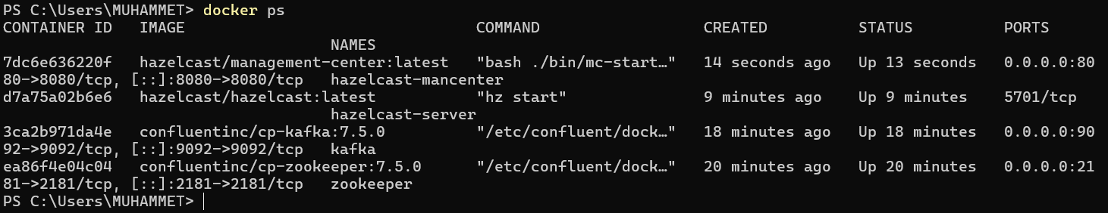

Hazelcast connection test

